Ideation Phase
Define the Problem Statements

Date | 31 January 2025
Team ID: __________
Project Name: AI WeatherWise
Maximum Marks | 2 Marks

Customer Problem Statement Template:
Create a problem statement to understand your customer's point of view. The Customer Problem Statement template helps you focus on what matters to create experiences people will love.
Problem  Statement (PS) | I am  (Customer) | I’m trying to | But | Because | Which makes me feel
PS-1
I am a daily user trying to know accurate local weather
A well-articulated customer problem statement allows you and your team to find the ideal solution for the challenges your customers face. Throughout the process, you’ll also be able to empathize with your customers, which helps you better understand how they perceive your product or service.
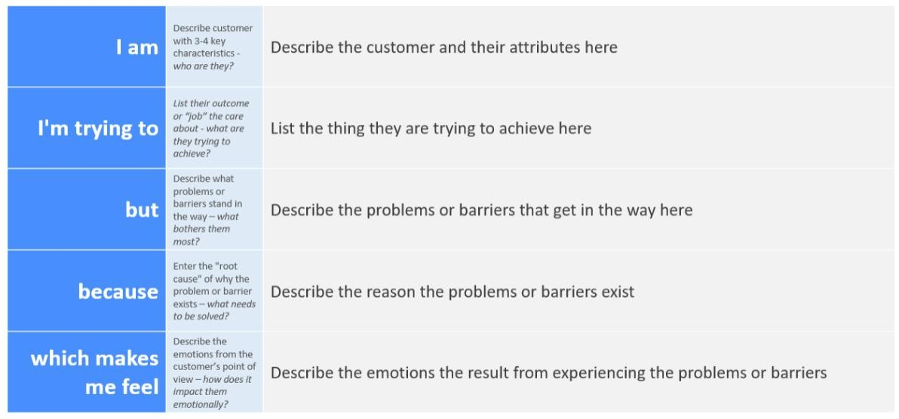
Project Focus: AI-based weather forecasting, alerts, and personalized weather information.
Example: AI WeatherWise User Problem Statement
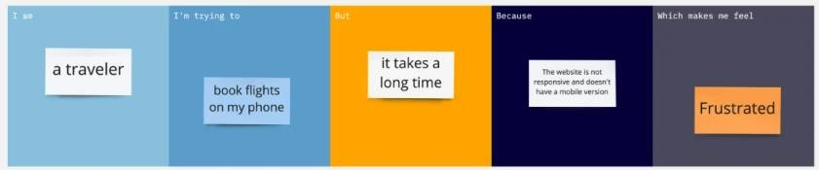
conditions. But I may not receive timely or easy-tounderstand information. Because sudden changes in temperature,
rainfall, or severe weather can affect my plans. Which makes me feel unprepared.
PS-2
I am a user trying to plan travel and outdoor activities using weather forecasts. But
existing information may not provide personalized
alerts or simple
recommendation s. Because weather conditions can change during the day. Which makes me feel unsure about whether it is safe or suitable to continue my plans.

